**// Subroutine : UpdateButtonClick_DESIGN_FABRICS()**

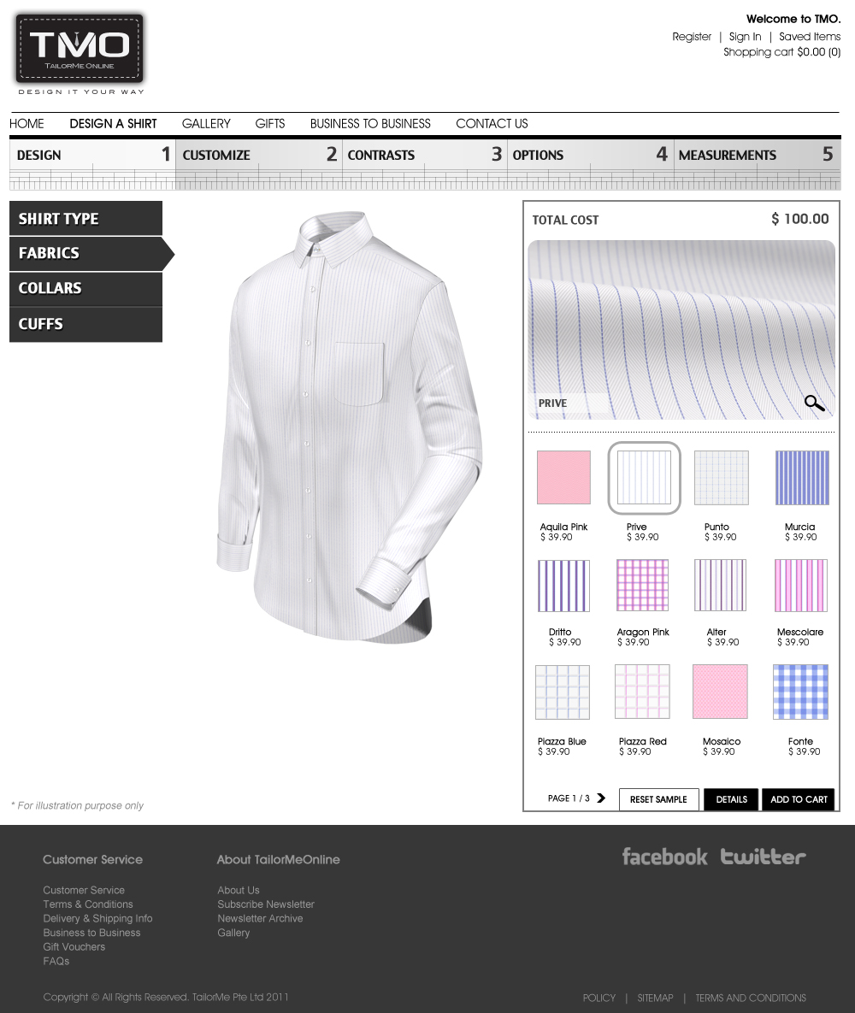

Upon clicking the Magnifying Glass at the bottom of the closeup window display :

Call Subroutine : DisplayFabricZoomIn();

Upon clicking the any fabric button:

// Note : Number the fabric icon in running number from 0001 onwards (ie. 0001, 0002, … , 0031)

BackDetails[4] = ConvertToString(Icon Number);

BackYoke[4] = ConvertToString(Icon Number);

ButtonLyr01[4] = ConvertToString(Icon Number);

FabricZoomIn[4] = ConvertToString(Icon Number);

FabricZoomOut[4] = ConvertToString(Icon Number);

PlacketLyr01[4] = ConvertToString(Icon Number);

PlacketLyr02[4] = ConvertToString(Icon Number);

PlacketContrastLyr01[4] = ConvertToString(Icon Number);

PlacketContrastLyr02[4] = ConvertToString(Icon Number);

PlacketContrastLyr03[4] = ConvertToString(Icon Number);

PlacketContrastLyr04[4] = ConvertToString(Icon Number);

TieFixLyr01[4] = ConvertToString(Icon Number);

TieFixLyr02[4] = ConvertToString(Icon Number);

TieFixLyr03[4] = ConvertToString(Icon Number);

CollarLyr01[4] = ConvertToString(Icon Number);

CollarLyr02[4] = ConvertToString(Icon Number);

CollarLyr03[4] = ConvertToString(Icon Number);

CollarLyr04[4] = ConvertToString(Icon Number);

CollarLyr05[4] = ConvertToString(Icon Number);

CuffLyr01[4] = ConvertToString(Icon Number);

CuffLyr02[4] = ConvertToString(Icon Number);

CuffLyr03[4] = ConvertToString(Icon Number);

ShirtLyr01[4] = ConvertToString(Icon Number);

ShirtLyr02[4] = ConvertToString(Icon Number);

ShirtLyr03[4] = ConvertToString(Icon Number);

ShirtLyr04[4] = ConvertToString(Icon Number);

ShirtLyr05[4] = ConvertToString(Icon Number);

ShirtLyr08[4] = ConvertToString(Icon Number);

ShirtLyr09[4] = ConvertToString(Icon Number);

ShirtLyr12[4] = ConvertToString(Icon Number);

ShirtLyr13[4] = ConvertToString(Icon Number);

ShirtLyr16[4] = ConvertToString(Icon Number);

Call Subroutine : RefreshFilenames();

Call Subroutine : DisplayFabricZoomOut(); // This updates the fabric window

Call Subroutine : DisplayFullview(); // This updates the full shirt window

**// End of Subroutine : UpdateButtonClick_DESIGN_FABRICS()**